Code:

1. Write a program using C++ to find the largest number from four integers.

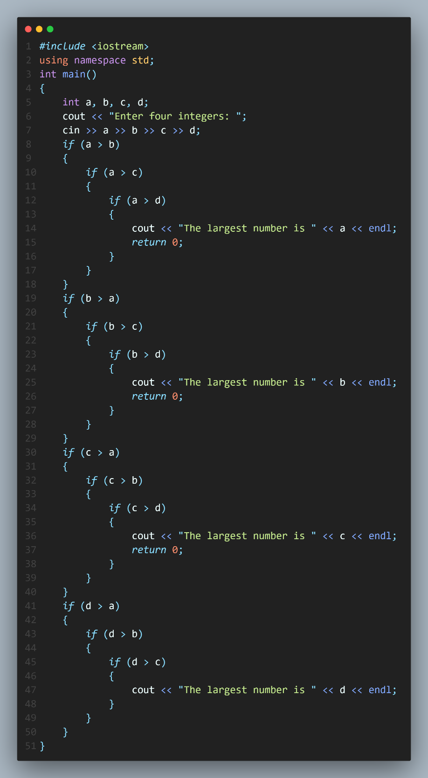

Output: 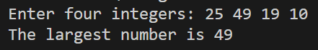

1. Write a program using C++ to calculate CGPA.

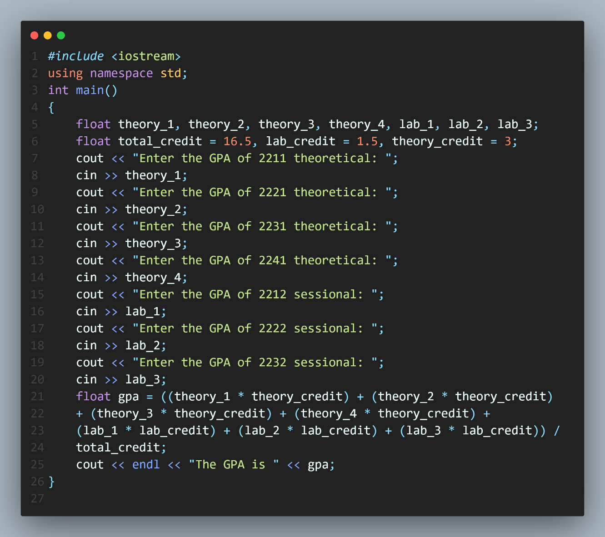

Output: 